Attention Safety Managers! Goldenrod offers economical, easy to use, mobile shaft pullers.

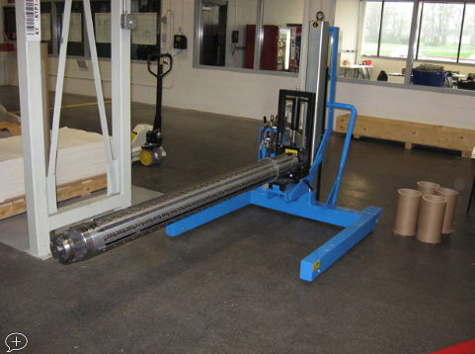The **SP-3000 Manual Shaft Puller** consists of a wheeled base with a support head and shaft clamp. The operator uses levers and a hydraulic hand-pump to raise and lower the support head; a second lever controls the clamping. The unit includes safety features that prevent the shaft from dropping should hydraulic pressure be lost. All movement is manual–the unit has been redesigned to be lighter and easier to maneuver.

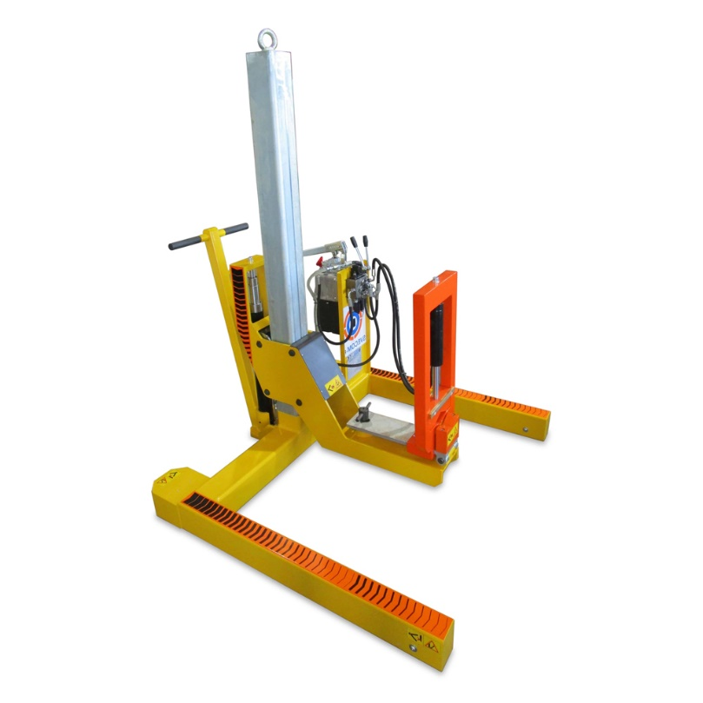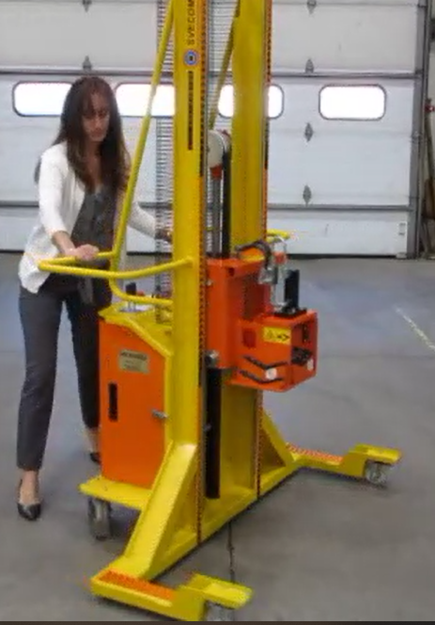

The **SP-3050 Manual Push/Pull – Electric Lift & Clamp Shaft Puller** consists of a wheeled base with a support head and a shaft clamp. The operator uses controls for electric motor to raise and lower the support head.  The fail-safe electric clamp securely grabs the shaft journal, allowing for easy retraction and insertion.   All movement is manual push/pull – the unit has been redesigned to be lighter and easier to maneuver.